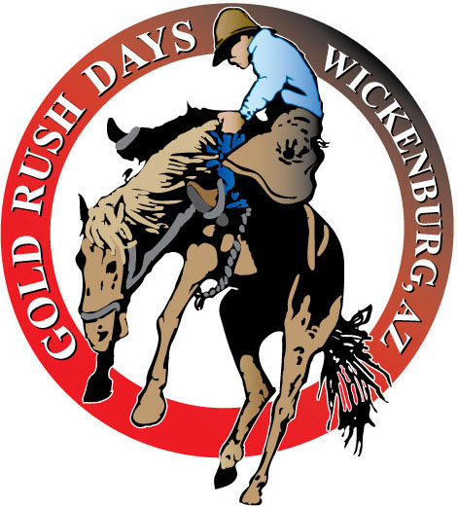
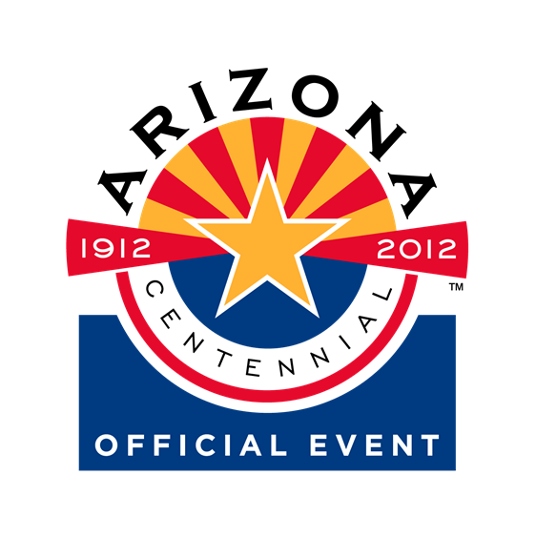
64th ANNUAL GOLD RUSH DAYS CELEBRATION & RODEO
HISTORIC WICKENBURG, ARIZONA
FEBRUARY 16TH-19TH, 2012

Sponsored by THE WICKENBURG CHAMBER OF COMMERCE & PARD’NERS!

THURSDAY, FEBRUARY 16TH
10:00AM-5PM – Visit the Desert Caballeros Western Museum
5:00 P.M. OPENING NIGHT FAMILY CARNIVAL -special wrist band price
7:30 P.M. DEL E. WEBB CENTER Presents: “Emerson Drive” $42Adults

FRIDAY, FEBRUARY 17th
9:00 A.M. –3 P.M. CLASSIC CAR SHOW – FRONTIER STREET
9:00 A.M. – 5: P.M. WICKENBURG ART CLUB – ARTISIAN FAIRE- Library & Stone Park
ARTS/CRAFTS/FAMILY CARNIVAL & More!
160 N. Valentine Street-Historic District – Wickenburg Community Center
10:00 A.M. OPENING CEREMONIES –Gold Rush Officials
Special Guest, Gunslinger & Performer, Joey Dillon
On historic Frontier Street in front of the Chamber Office – Historic Santa Fe Depot
11:00 A.M. SENIOR PRO RODEO SLACK – Everett Bowman Rodeo Arena- $5 admission
12Noon-5PM GOLD PANNING
7:00 P.M. DESERT STAGERS MELODRAMA- SAGUARO THEATRE
7:30 P.M. “Emerson Drive” @ The Webb Center – 2nd Performance

SATURDAY, FEBRUARY 18th
9:00 A.M. – 5 P.M. WICKENBURG ART CLUB ARTISIAN FAIRE
CHAMBER ARTS/CRAFTS-FAMILY CARNIVAL
9:00 A.M. ARIZONA GUNSLINGERS –GUN FIGHTS ON FRONTIER STREET
10:00 A.M. GOLD RUSH PARADE –Sponsored by Cox Communications
Parade Theme: “CENTENNIAL GOLD!” 4th Largest Parade in AZ
11:00 A.M. WICKENBURG SADDLE CLUB BBQ-Community Center-$8-$4.50 Child
11AM-5 PM GOLD PANNING
2:00 P.M. SENIOR PRO & GCPRA RODEO – EVERETT BOWMAN ARENA
Admission: $10 adults; $8 Seniors (60+) $6 Student (13-18)
Child $3 (5-12) Under 5 – FREE (Gates open at 12 Noon)
7:00 P.M. DESERT STAGERS MELODRAMA – SAGUARO THEATRE
8:30 P.M. GOLD RUSH RODEO DANCE – Band TBA
MIDNIGHT $8-$15 couple– No Host Bar –Community Center

SUNDAY, FEBRUARY 19TH
10:00 A.M. –5PM WICKENBURG ART CLUB ARTISIAN FAIRE
10:00 A.M. - 5PM. CHAMBER ARTS & CRAFTS, FAMILY CARNIVAL,
FREE STAGE ENTERTAINEMENT, PHOTO DISPLAY & MUCH MORE!
10:00 A.M. MUCKING & DRILLING CONTEST – FESTIVAL AREA
10AM-4PM GOLD PANNING
1:00 P.M. CHAMPIONSHIP GOLD PANNING CONTEST
2:00 P.M. SENIOR PRO & GCPRA RODEO – Everett Bowman Arena
7:00 P.M. DESERT STAGERS MELODRAMA – SAGUARO THEATRE

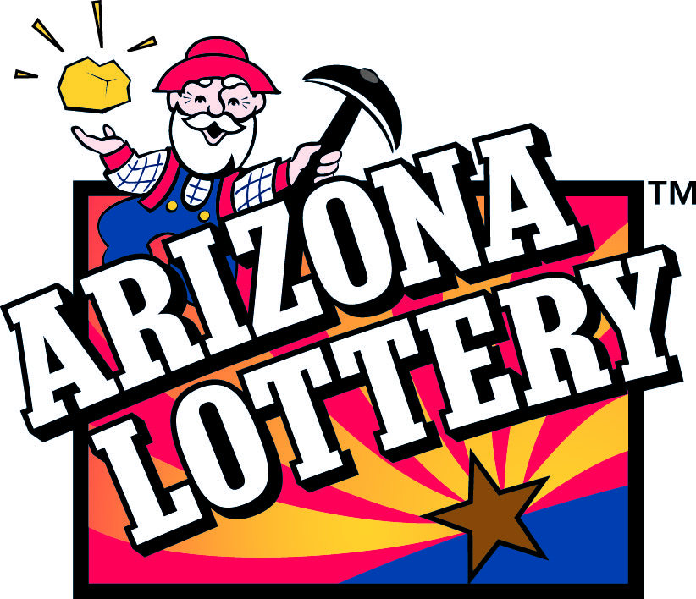
MELODRAMA, RODEO & WESTERN DANCE TICKETS AVAILABLE FROM THE CHAMBER 1-800-942-5242 – WWW.WICKENBURGCHAMBER.COM
*Concert Tickets for Emerson Drive sold only from THE Webb Center Box Office.

SPONSORED IN PART BY THE ARIZONA LOTTERY

